Course code: CSE 4104 | Credit: .75
Course Name: Engineering Drawing Lab | Semester: Winter

Lab 6
Name of Experiment: Array and Block
  - Objective of this Lab
Objective of this lab is to learn how we can draw multiple objects at time and also how to make them a single unit.
Learning Outcomes
Upon completion of this lab you are expected to be able to-
- Create array of same type of object.
- Create a block from several objects.
  - Topics
Today we will learn the following commands-
Commands | Shortcut
Array | Array/AR
Block | Block/ B

- Array
- Type AR (for array command). Look at the dialog box shown below: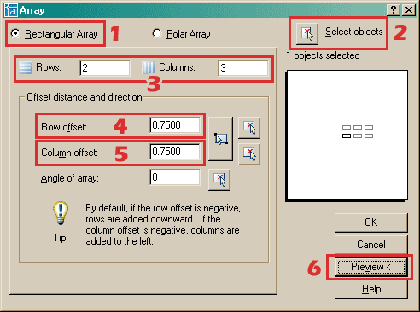
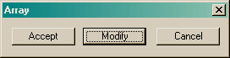
- Start the ARRAY command again (this is for polar array)
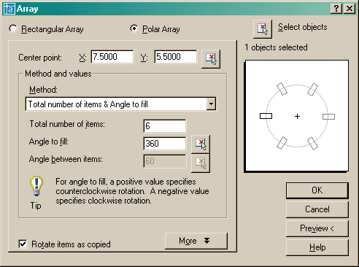
Example of Rectangular Array
Example of Polar Array

- Block
- Blocks are a single entity. This means that you can modify (move, copy, rotate) a block by selecting only one object in it.
- You can build up a library of blocks consisting of the parts that you require many times in your workday. These blocks can be stored in a separate folder and even on a network so that all drafters have access to them.
- Using blocks can help keep your file size down. AutoCAD stores block definitions in its database. When you insert a block, AutoCAD only stores the name of the block, its location (insertion point), scale and rotation. This can be very noticeable in large drawing.

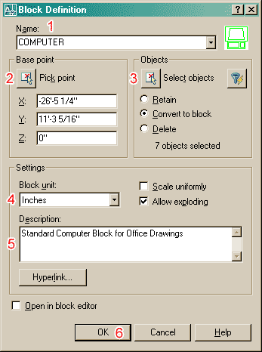
Now that you have created a block, it's time to insert it. Start the Insert command by typing I <ENTER>. You will see this dialog box on the screen:
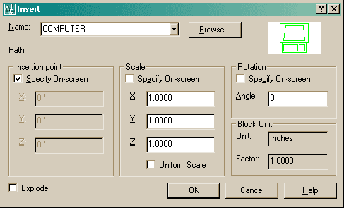

Make sure that the Insertion Point - Specify On-screen box is checked, and the Explode button is not checked. The Scale - Specify On-screen should not be checked. Then press the OK button. Pick anywhere on your screen and you will see the block appear.
  - Assignments
Use BLOCK command to draw the following:
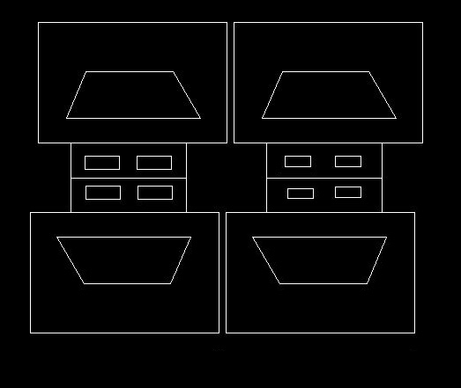

Use ARRAY command to draw the followings:
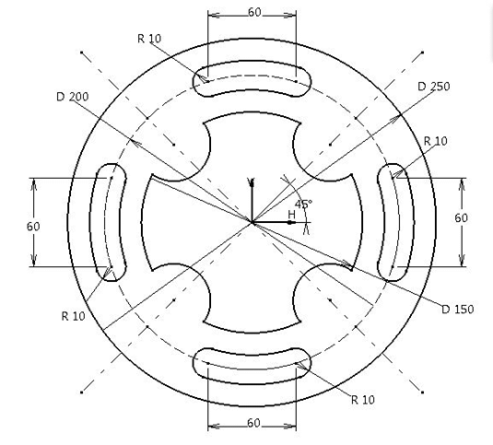

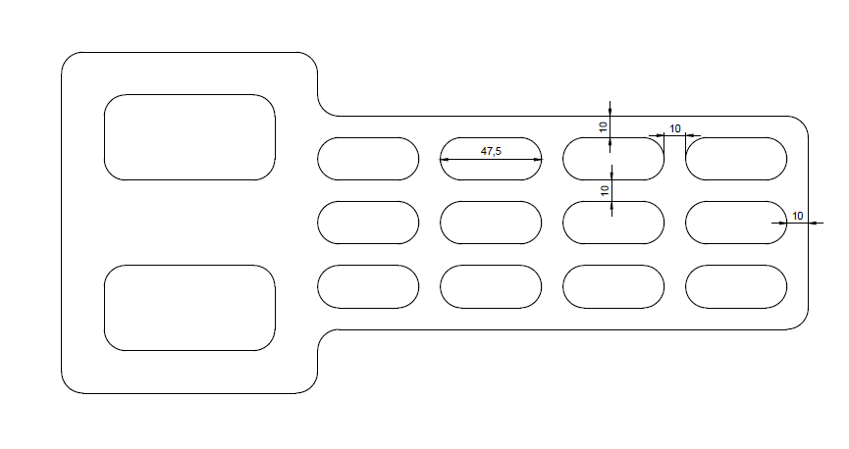
Use the following figure from previous lab for different dimensions.

